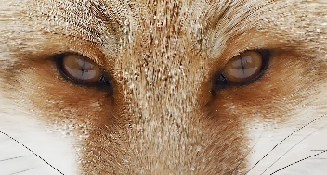 |  |  |  |  | Antonio powell  - Jacksonville, Fl | 904-888-1919https://github.com/s2720898/Seahawks- | greatsiteaddress.com  Licensed pharmacist with over 7 years of experience in retail and clinical pharmacy settings. Strong expertise in dispensing medications, providing patient counseling, and collaborating with healthcare providers to optimize patient care.

education
aug 2026  DEC 2026 |  |  |  | Pharmacist, Lamiere labs  Dispense medications accurately and efficiently, ensuring compliance with state and federal laws.  Provide patient education on medication therapy, side effects, and drug interactions.
Mar 20XX-  Jan 20XX |  |  |  | CGS1060 INTRO TO COMPUTERS  Intermediate experience with Microsoft Word, Excel, Power Point and Access. Created edited  Formatted multiple Word document. Experienced using the internet to research a topic and

experience
June 20XX |  |  |  | Doctor of Pharmacy, jasper university  Received the Dean's List award for maintaining a high grade point average and academic excellence.
May 20XX |  |  |  | Bachelor of Science in Biology, bellows college  The student was recognized as the Most Outstanding Pharmacy Student of the Year.
Skills |  |  |  |  |  |  | Activities
- Strong knowledge of medication therapy, drug interactions, and side effects  - Excellent communication skills, both verbal and written  - Attention to detail and accuracy in medication dispensing and record-keeping  - Ability to collaborate effectively with healthcare providers and other team members |  |  |  |  |  |  | Active member of the National Association of Pharmacy Professionals (NAPP) and participated in various volunteer and networking events aimed at promoting the role of pharmacists in healthcare.

